

**Group Members :**

*M . Faseeh ur Rehman*

*Fahad Imran*

*Mishma Kenneth*

*Abdulrehman Amjad Bajwa*

**Submitted to :**

*Sir Bilal*

**Section :**

*U*

# Project Name : Electronic Voting System

Detailed discription of Electronic Voting System:

An electronic voting system (e-voting) , revolutionizes the traditional method of casting and counting votes by employing block chain technology. This system aimed to streamline the voting process , enhance accuracy , speed up vote counting and potentially offer additional features and capabilities.In an e-voting system, voters uses computers or mobile devices to cast their votes. These devices are equipped with user-friendly interfaces that allow voters to cast their vote. This transition from manual marking of paper ballots to block chain technology offers several advantages.

Efficiency and speed are among the significant benefits of electronic voting systems. Long queues and wait times at polling stations can be significantly reduced as the voting process becomes more streamlined. Vote counting is automated, eliminating the need for manual sorting and tallying of paper ballots. As a result, election results can be delivered much faster, which is especially advantageous for large-scale elections where timely results are crucial. The automation of vote counting in electronic voting systems also helps to minimise human error. Traditional voting systems often involve manual processes that are susceptible to errors such as misreads, misinterpretations of voter intent, or data entry mistakes. Through block chain technology, electronic voting systems mitigate these risks and deliver more accurate and reliable results.

Electronic voting systems operate through a series of interconnected processes. When a voter opens the app on a computer or a mobile device , equipped with a user-friendly interface. The voter interacts with the app , add his national identity number then his national identity number is verified. Verifiability are easy because this app is linked with NADRA so there is no chance of rigging in election, once his or her verification is completed, voter could casts his or her vote. Very less time consuming the person enter nation identity card number and then they cast the vote just selecting. Once the voter has completed their ballot, the electronic system securely stores the vote in its memory. After the voting period ends, the votes are tallied and counted electronically. The system employs software and algorithms specifically designed for this purpose. The software aggregates and tabulates the votes, producing an accurate count. This automated process significantly reduces the time required for counting, allowing for a faster declaration of results.

To ensure the integrity and security of the electronic voting system, several measures are implemented. Strong encryption techniques and secure storage protocols protect the stored votes from hacking or unauthorised access. Robust authentication mechanisms authenticate voters, preventing duplicate or fraudulent voting. In some cases, electronic voting systems may also incorporate built-in audit trails and verification mechanisms, allowing for post-election audits

to verify the accuracy and integrity of the voting process. Furthermore, the electronic voting system may include redundancy and backup measures to address technical failures or system errors. This ensures that the voting process remains reliable and uninterrupted throughout the election. Overall, electronic voting systems combine user-friendly interfaces, secure storage, automated counting, and stringent security measures to streamline the voting process, enhance accuracy, and facilitate efficient and trustworthy elections.

**Functional Requirements:**

**Voter Registration :**

The system should allow the registration of eligible voters.

It should provide a secure and accurate method for authenticating voters, ensuring that only authorized individuals can cast their votes.

**Voter Education Integration:**

The system should integrate educational features to guide voters on the voting process and its importance.

**Ballot Casting:**

The EVM should enable voters to cast their votes securely and privately.

It should accurately record and store the selected choices made by the voters.

**Candidate Information Management:**

The system should store and manage information about candidates, political parties, and relevant election details.

It should allow for the dynamic addition or removal of candidates based on the electoral process.

**Multi-language Support:**

The system should support multiple languages to accommodate voters with different language preferences.

**Voting Process:**

The system should provide a user-friendly interface for voters to access and cast their votes electronically.

Voters should be able to view the ballot, select their preferred candidates or options, and review their selections before finalizing their votes.

**Verification Mechanism:**

Voters should receive a confirmation or verification message after casting their votes.

**Vote Preview:**

The system should allow voters to review their choices before finalizing their votes.

**Real-time Monitoring:**

The system should provide real-time monitoring of the voting process, including the number of votes cast and any irregularities.

It should allow authorized personnel to view the ongoing results securely.

**Authentication Data:**

To ensure secure access to the electronic voting system, authentication data is needed.

**Audit Trail:**

The EVM should maintain a comprehensive and secure audit trail of all activities during the election.

This includes recording any attempts at tampering or unauthorized access.

**Result Generation:**

The system should be capable of generating accurate and verifiable election results based on the votes cast.

It should ensure transparency in the result generation process.

**Data Transmission:**

If applicable, the system should securely transmit voting data from the polling stations to a central server for consolidation.

The transmission process should be resistant to tampering.

**Multiple Voting Stations Support:**

The system should support multiple voting stations in different locations, ensuring a scalable and flexible setup.

**Integration:**

The system should be compatible and able to integrate with other relevant systems, such as voter registration databases or result reporting platforms.

**Interoperability**

It should support standard data exchange formats to facilitate interoperability with external systems or third-party applications.

**Non-Functional Requirements:**

**Security:**

The EVM should implement robust security measures to prevent unauthorized access, tampering, or hacking.

It should use encryption to protect sensitive data during transmission and storage.

**Reliability:**

The system should be highly reliable, ensuring minimal downtime during the election period.

It should have backup mechanisms to handle unexpected failures.

**Usability:**

The user interface should be intuitive and easy to use, catering to voters of varying technical proficiency.

It should include clear instructions for voters and poll workers.

**Scalability:**

The system should be scalable to accommodate a varying number of voters and candidates in different elections.

It should handle an increase in load without compromising performance.

**Accessibility**:

The EVM should be designed to be accessible to voters with disabilities, ensuring inclusivity in the voting process.

It should comply with accessibility standards to accommodate diverse needs.

**Integrity:**

The system should ensure the integrity of both the voting process and the stored data.

Any attempt to manipulate or alter the system should be detected and prevented.

**Compliance:**

The EVM should comply with relevant legal and regulatory requirements.

It should adhere to standards set by election commissions or governing bodies.

**ERD:**

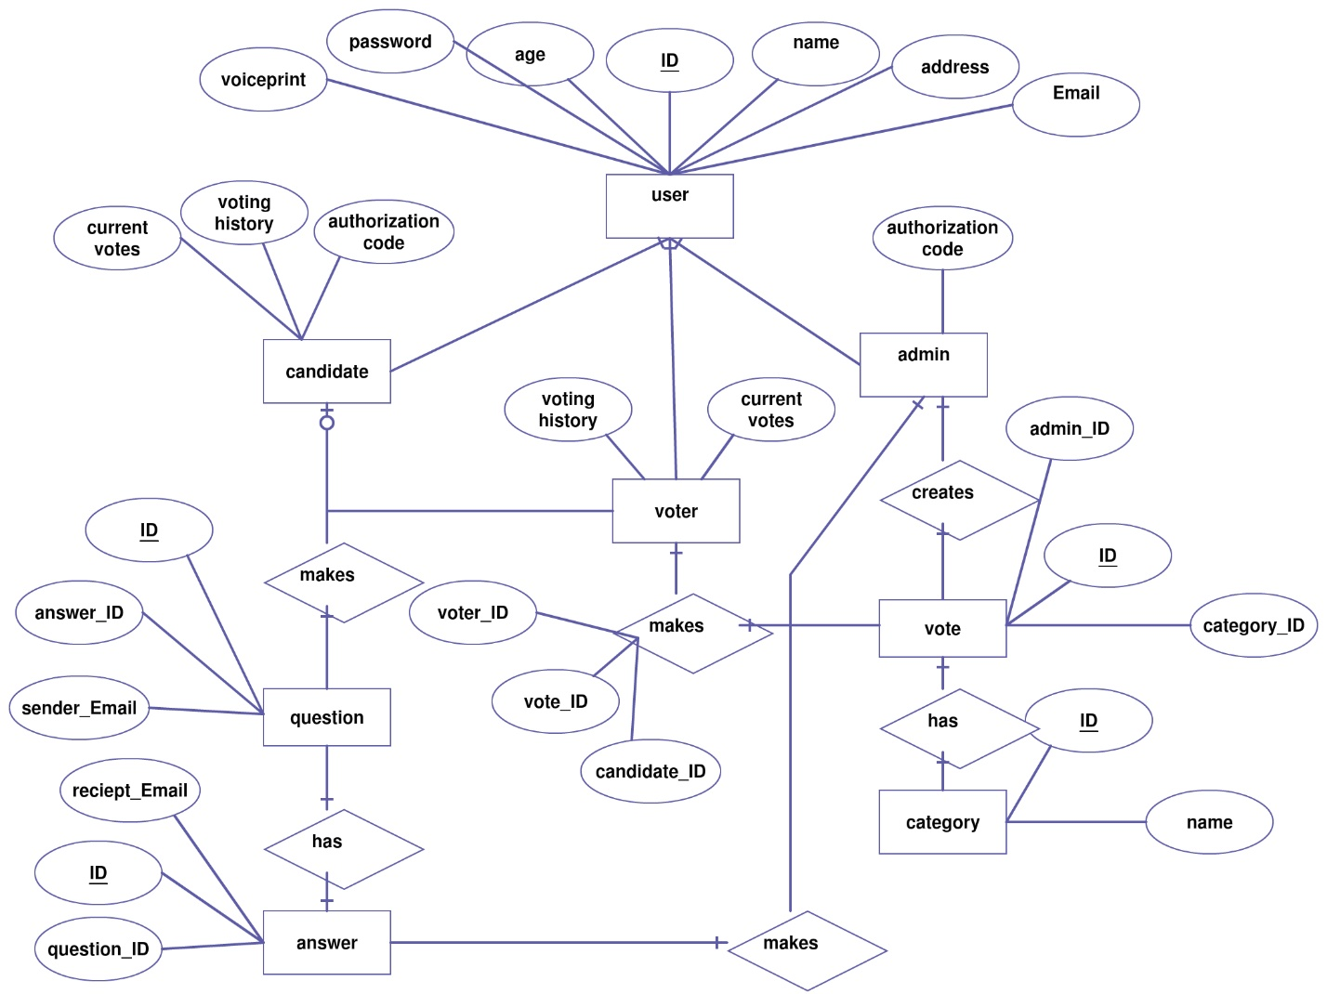

**Conceptual Class Model and Activity Diagram :**



* **State Transition Diagrams (STDs):**

